**Create K8s Cluster**

1. **Install virtual box and vagrant to Create cluster.**

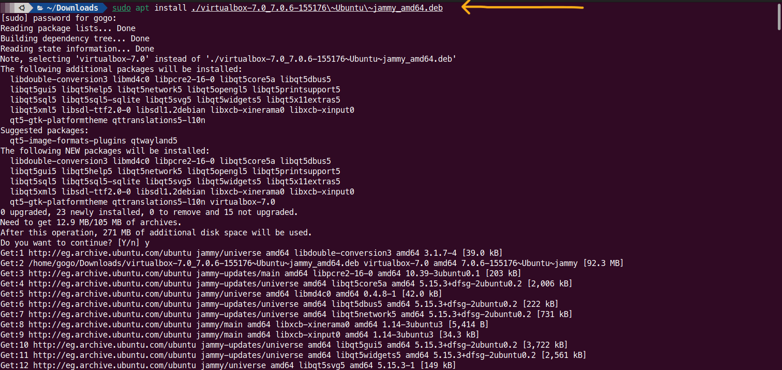

1. **Run command (vagrant up) to install (master & worker) and connect.**

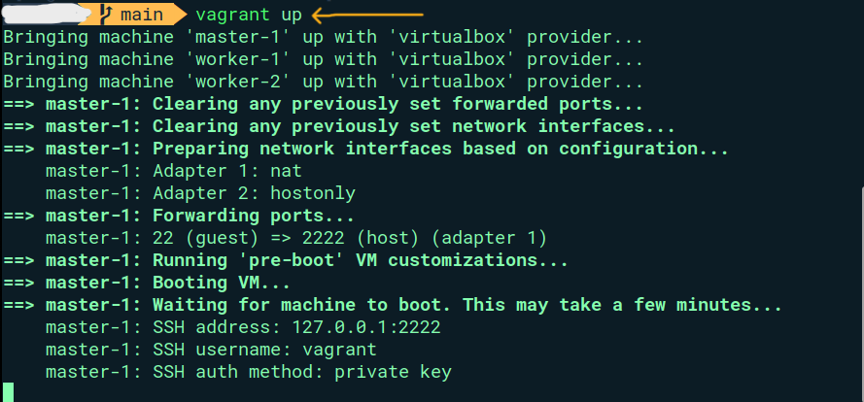

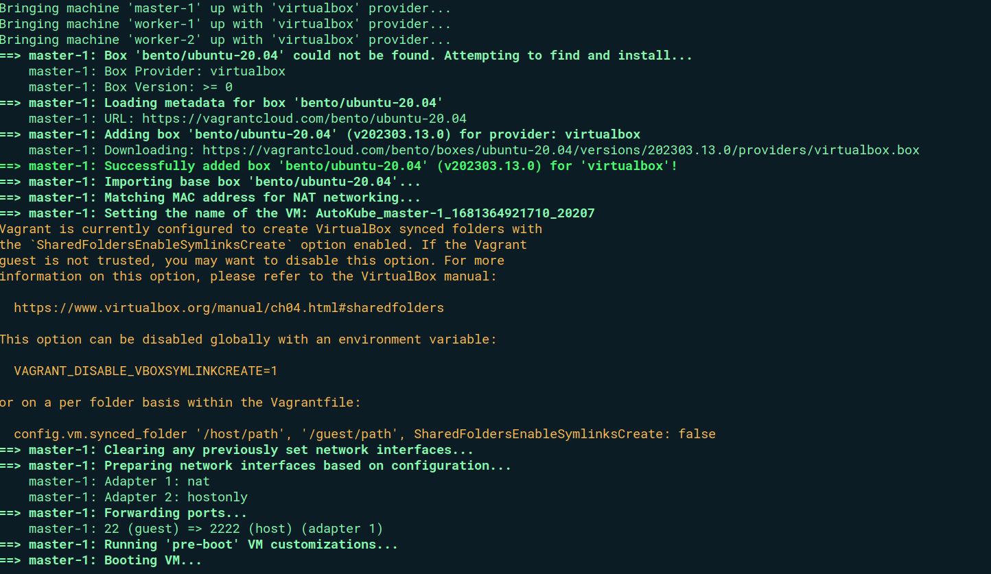

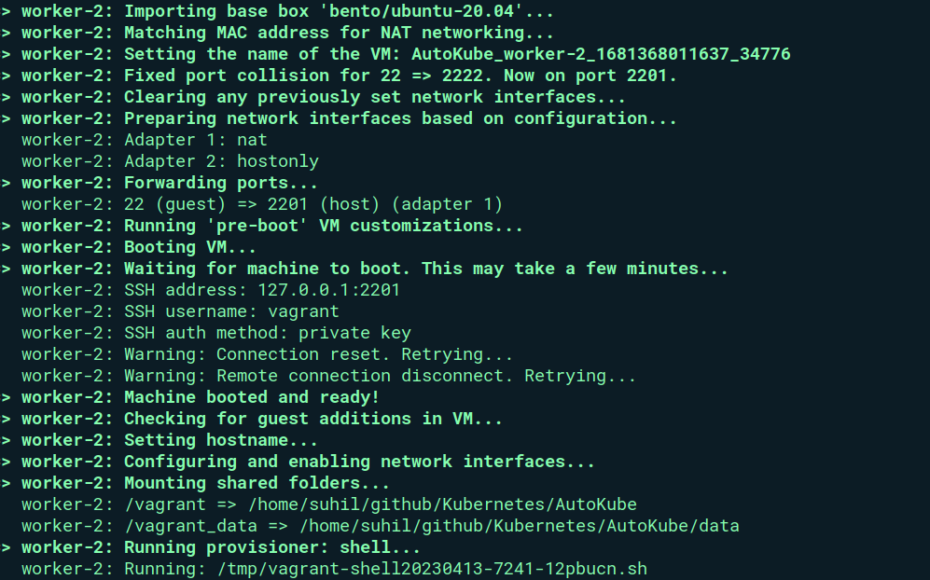

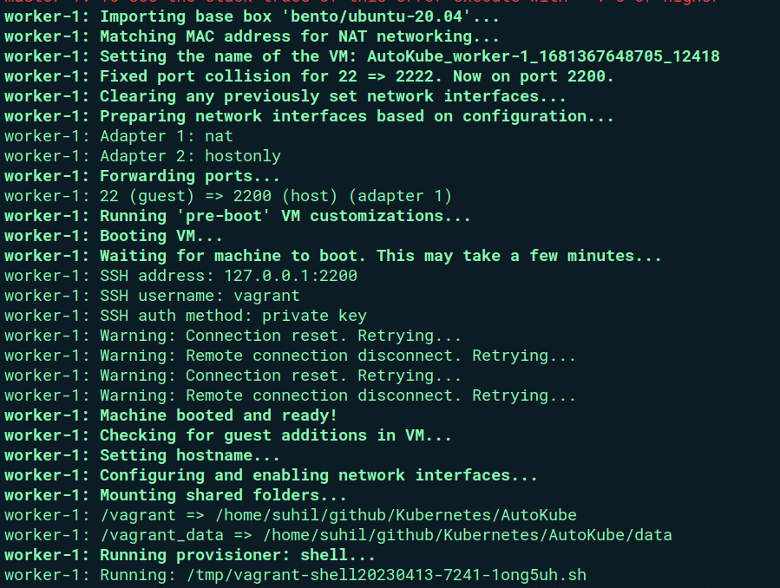

1. **connected to master by ssh.**

**(Now can you get any command into node)**

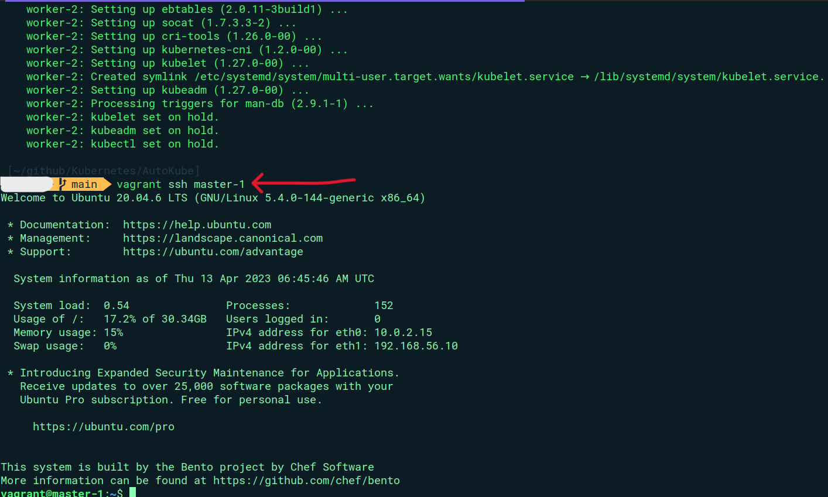

1. **Configuration file**

